**4124 Ahmer Aziz**

**Question 1:**

using System;

using System.Collections.Generic;

using System.Linq;

using System.Text;

using System.Threading.Tasks;

namespace Program_1

{

class Program

{

static void Main(string[] args)

{

int n, sum=0, product=1;

Console.WriteLine("Enter Length of Array: ");

n = Convert.ToInt32(Console.ReadLine());

int[] arr = new int[n];

Console.WriteLine("Enter Array Element: ");

for (int i = 0; i < n; i++)

{

arr[i] = Convert.ToInt32(Console.ReadLine());

}

for (int i = 0; i < n; i++)

{

Console.WriteLine("Array Elements: "+ arr[i]);

sum += arr[i];

product *= arr[i];

}

Console.WriteLine("Sum of Array Element: "+ sum);

Console.WriteLine("Product of Array Element: "+ product);

}

}

}

**Output:**

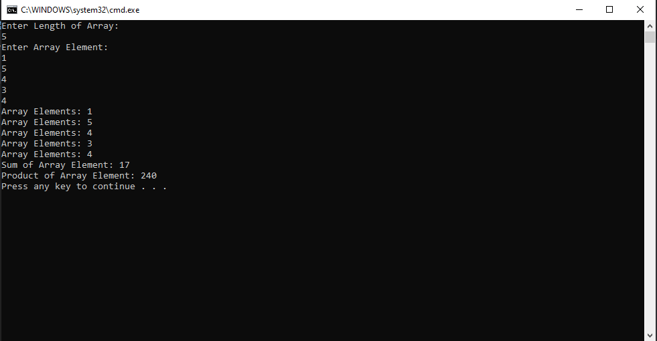

**Question# 2:**

using System;

using System.Collections.Generic;

using System.Linq;

using System.Text;

using System.Threading.Tasks;

namespace Program_1

{

class Program

{

static void Main(string[] args)

{

int n, firstLargest=0, secondLargest=0;

Console.WriteLine("Enter Length of Array: ");

n = Convert.ToInt32(Console.ReadLine());

int[] arr = new int[n];

Console.WriteLine("Enter Array Element: ");

for (int i = 0; i < n; i++)

{

arr[i] = Convert.ToInt32(Console.ReadLine());

if (firstLargest < arr[i])

{

secondLargest = firstLargest;

firstLargest = arr[i];

}

else if (secondLargest < arr[i])

{

secondLargest = arr[i];

}

}

Console.WriteLine("First Largest Element: "+ firstLargest);

Console.WriteLine("Second Largest Element: "+ secondLargest);

}

}

}

**Output:**

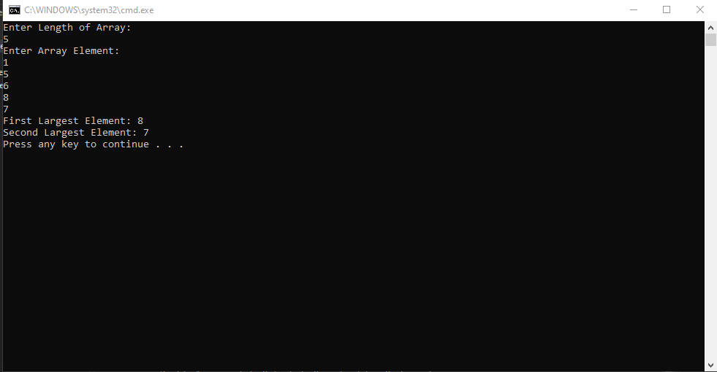

**Question 3:**

using System;

using System.Collections.Generic;

using System.Linq;

using System.Text;

using System.Threading.Tasks;

namespace Program_1

{

class Program

{

public static bool prime(int number)

{

int flag = 0;

for (int i = 2; i < number / 2; i++)

{

if (number % i == 0)

{

flag = 1;

break;

}

}

if (flag == 1)

return false;

else

return true;

}

static void Main(string[] args)

{

int n, i, j = 0, k = 0;

Console.WriteLine("Enter Length of Array: ");

n = Convert.ToInt32(Console.ReadLine());

int[] arr = new int[n];

Console.WriteLine("Enter Array Element: ");

for (i = 0; i < n; i++)

{

arr[i] = Convert.ToInt32(Console.ReadLine());

}

for (i = 0; i < n; i++)

{

if (prime(arr[i]))

{

for (j = i; j < n; j++)

{

arr[j] = arr[j + 1];

}

i--;

n--;

}

}

Console.WriteLine("Enter Array Element After Deleting Prime: ");

for (i = 0; i < n; i++)

{

Console.WriteLine(arr[i]);

}

}

}

}

**Question 4:**

using System;

using System.Collections.Generic;

using System.Linq;

using System.Text;

using System.Threading.Tasks;

namespace Program_1

{

class Program

{

static void Main(string[] args)

{

int n;

Console.WriteLine("Enter Length of Array: ");

n = Convert.ToInt32(Console.ReadLine());

int[] arr = new int[n];

Console.WriteLine("Enter Array Element: ");

for (int i = 0; i < n; i++)

{

arr[i] = Convert.ToInt32(Console.ReadLine());

}

for (int i = 0; i < n; i++)

{

for (int j = i + 1; j < n; j++)

{

if (arr[i] == arr[j])

{

for (int k = j; k < n - 1; k++)

{

arr[k] = arr[k + 1];

}

n--;

j--;

}

}

}

for (int i = 0; i < n; i++)

{

Console.WriteLine("Array Element After Removing Duplicate: "+ arr[i]);

}

}

}

}

**Output:**

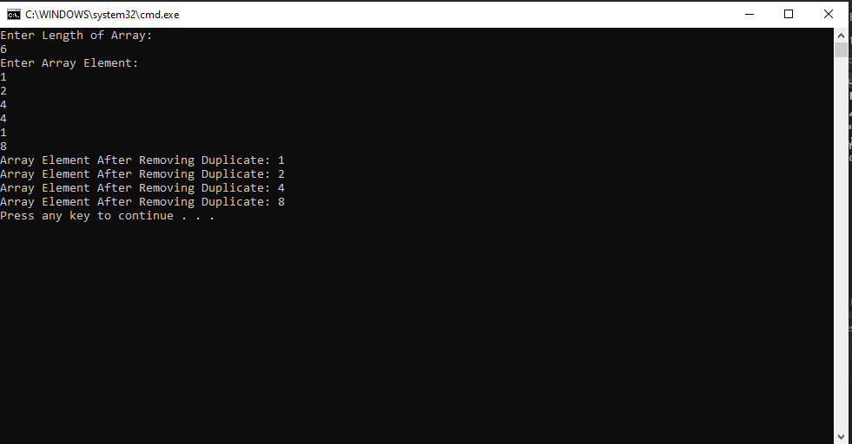

**Question 5:**

using System;

using System.Collections.Generic;

using System.Linq;

using System.Text;

using System.Threading.Tasks;

namespace Program_1

{

class Program

{

static void Main(string[] args)

{

int n;

Console.WriteLine("Enter Length of Array: ");

n = Convert.ToInt32(Console.ReadLine());

int[] arr = new int[n];

int[] dup = new int[n];

Console.WriteLine("Enter Array Element: ");

for (int i = 0; i < n; i++)

{

arr[i] = Convert.ToInt32(Console.ReadLine());

}

for (int i = 0; i < n; i++)

{

for (int j = i + 1; j < n; j++)

{

if (arr[i] == arr[j])

{

dup[i] = arr[i];

}

}

}

for (int i = 0; i < n; i++)

{

if(dup[i]>0)

Console.WriteLine("Duplicate Element"+ i +": "+ dup[i]);

}

}

}

}

**Output:**

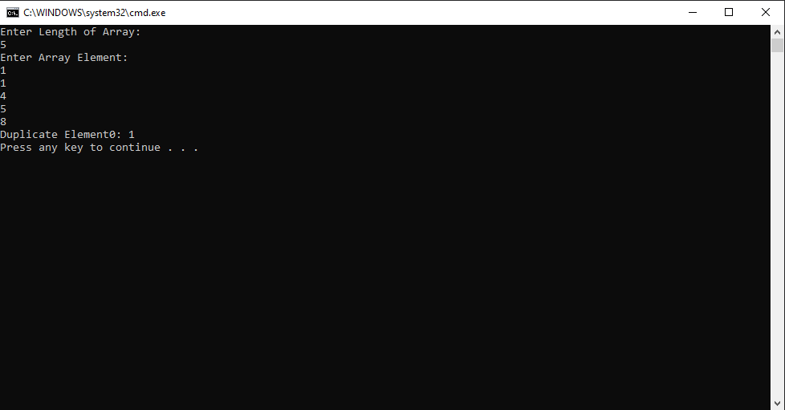

**Question 6:**

using System;

using System.Collections.Generic;

using System.Linq;

using System.Text;

using System.Threading.Tasks;

namespace Program_1

{

class Program

{

static void Main(string[] args)

{

int n, negativeIntegar=0,positiveIntegar=0,sum=0;

double avg;

Console.WriteLine("Enter Length of Array: ");

n = Convert.ToInt32(Console.ReadLine());

int[] arr = new int[n];

int[] dup = new int[n];

Console.WriteLine("Enter Array Element: ");

for (int i = 0; i < n; i++)

{

arr[i] = Convert.ToInt32(Console.ReadLine());

}

for (int i = 0; i < n; i++)

{

sum = sum + arr[i];

if (arr[i] >= 0)

positiveIntegar++;

else

negativeIntegar++;

}

avg = Convert.ToDouble(sum) / n;

Console.WriteLine("Positive Integar: " + positiveIntegar);

Console.WriteLine("Negative Integar: " + negativeIntegar);

Console.WriteLine("Sum of Array: " + sum);

Console.WriteLine("Average: " + avg);

}

}

}

**Output:**

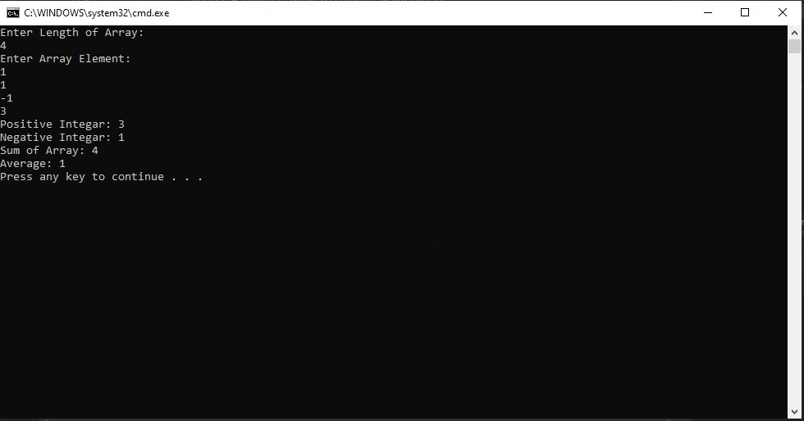

**Question# 7:**

using System;

using System.Collections.Generic;

using System.Linq;

using System.Text;

using System.Threading.Tasks;

using System.Text.RegularExpressions;

namespace Program_1

{

class Program

{

static void Main(string[] args)

{

int vowel=0;

string text;

text = "CureMD";

int n=text.Length;

for (int i = 0; i < n; i++)

{

if (text[i] == 'a' || text[i] == 'e' || text[i] == 'i' || text[i] == 'o' || text[i] == 'u' || text[i] == 'A' || text[i] == 'E' || text[i] == 'I' || text[i] == 'O' || text[i] == 'U')

{

vowel++;

}

}

Console.Write("The total number of vowel in the string is : {0}\n", vowel);

Console.WriteLine("Orginal string: " + text);

Console.WriteLine("After removing all the vowels from the said string: " + vowel(text));

}

public static string vowel(string text)

{

return new Regex(@"[aeiouAEIOU]").Replace(text, "");

}

}

}

**Output:**

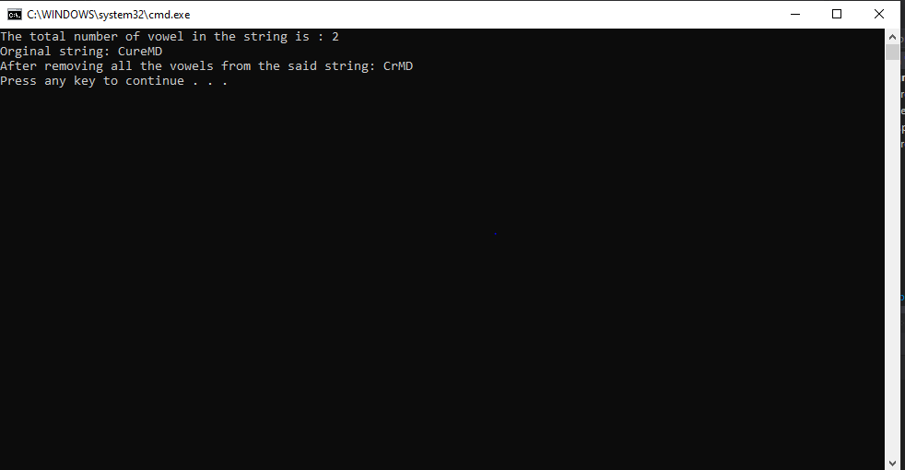

**Question# 8:**

using System;

using System.Collections.Generic;

using System.Linq;

using System.Text;

using System.Threading.Tasks;

using System.Text.RegularExpressions;

namespace Program_1

{

class Program

{

static void Main(string[] args)

{

int n, i;

float sum = 0;

Console.WriteLine("Enter Length of Array: ");

n = Convert.ToInt32(Console.ReadLine());

float[] arr = new float[n];

Console.WriteLine("Enter Array 1 Element: ");

for (i = 0; i < n; i++)

{

arr[i] = float.Parse(Console.ReadLine());

}

for (i = 0; i < n; i++)

{

Console.WriteLine("Array Element: " + arr[i]);

}

Console.WriteLine("Array Element after Addition: ");

for (i = 0; i < n; i++)

{

sum += arr[i];

Console.WriteLine("Array: "+sum);

}

}

}

}

**Output:**

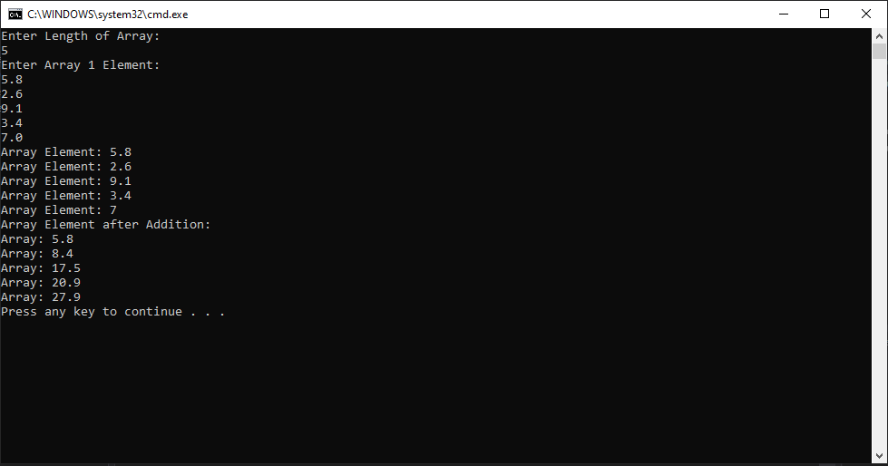

**Question# 9:**

using System;

using System.Collections.Generic;

using System.Linq;

using System.Text;

using System.Threading.Tasks;

using System.Text.RegularExpressions;

public static class Extension

{

public static T[] Concat<T>(this T[] arr, params T[] arr2)

{

if (arr == null)

{

return arr2;

}

if (arr2 == null)

{

return arr;

}

T[] result = new T[arr.Length + arr2.Length];

arr.CopyTo(result, 0);

arr2.CopyTo(result, arr.Length);

return result;

}

}

namespace Program_1

{

class Program

{

static void Main(string[] args)

{

int n, i;

Console.WriteLine("Enter Length of Array: ");

n = Convert.ToInt32(Console.ReadLine());

int[] arr = new int[n];

int[] arr2 = new int[n];

Console.WriteLine("Enter Array 1 Element: ");

for (i = 0; i < n; i++)

{

arr[i] = Convert.ToInt32(Console.ReadLine());

}

Array.Sort(arr);

Console.Write("\nThe Array 1 elements after sort: ");

for (i = 0; i < n; i++)

{

Console.Write("{0} ", arr[i]);

}

Console.WriteLine("\nEnter Array 2 Element: ");

for (i = 0; i < n; i++)

{

arr2[i] = Convert.ToInt32(Console.ReadLine());

}

Array.Sort(arr2);

Console.Write("\nThe Array 2 elements after sort: ");

for (i = 0; i < n; i++)

{

Console.Write("{0} ", arr2[i]);

}

Console.Write("\nThe Array 3 elements after concat: ");

int[] result = arr.Concat(arr2);

Console.WriteLine(String.Join(",", result));

Array.Sort(result);

Console.Write("\nThe Array 3 elements after Sort: ");

for (i = 0; i < result.Length; i++)

{

Console.Write("{0} ", result[i]);

}

}

}

}

**Output:**

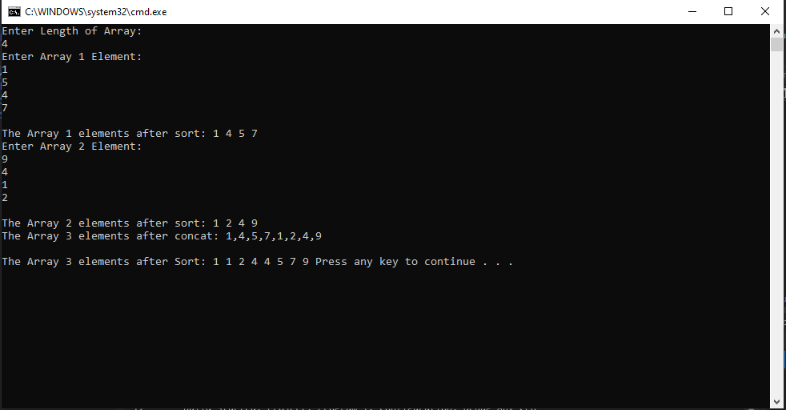

**Question# 10:**

using System;

using System.Collections.Generic;

using System.Linq;

using System.Text;

using System.Threading.Tasks;

namespace Program_1

{

class Program

{

static void Main(string[] args)

{

int n,i,j=0,k=0;

Console.WriteLine("Enter Length of Array: ");

n = Convert.ToInt32(Console.ReadLine());

int[] arr = new int[n];

int[] arr2 = new int[n];

int[] arr3 = new int[n];

Console.WriteLine("Enter Array Element: ");

for (i = 0; i < n; i++)

{

arr[i] = Convert.ToInt32(Console.ReadLine());

}

for (i = 0; i < n; i++)

{

if (arr[i] % 2 == 0)

{

arr2[j] = arr[i];

j++;

}

else

{

arr3[k] = arr[i];

k++;

}

}

Console.Write("\nThe Even elements are :");

for (i = 0; i < j; i++)

{

Console.Write("{0} ", arr2[i]);

}

Console.Write("\nThe Odd elements are :");

for (i = 0; i < k; i++)

{

Console.Write("{0} ", arr3[i]);

}

}

}

}

**Output:**

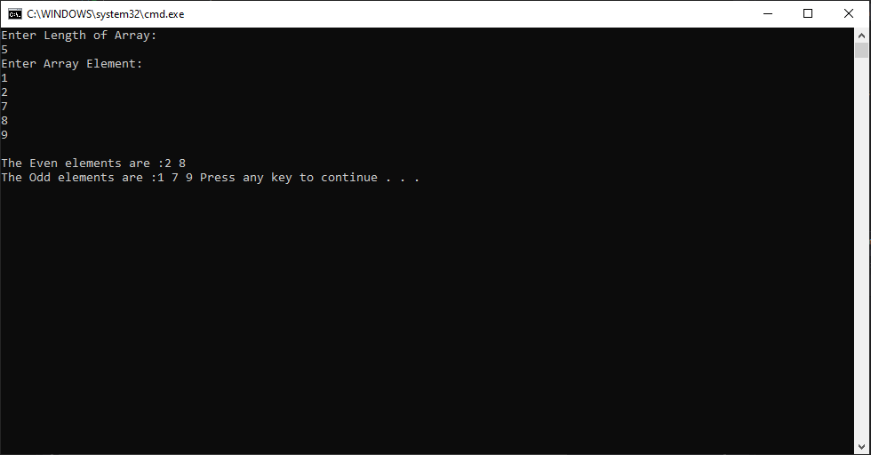

**Question 11:**

using System;

using System.Collections.Generic;

using System.Linq;

using System.Text;

using System.Threading.Tasks;

namespace Program_1

{

class Program

{

static void Main(string[] args)

{

int n,i,j=0,k=0;

Console.WriteLine("Enter Length of Array: ");

n = Convert.ToInt32(Console.ReadLine());

int[] arr = new int[n];

Console.WriteLine("Enter Array Element: ");

for (i = 0; i < n; i++)

{

arr[i] = Convert.ToInt32(Console.ReadLine());

}

int first = arr[0];

arr[0] = arr[arr.Length - 1];

arr[arr.Length - 1] = first; using System;

using System.Collections.Generic;

using System.Linq;

using System.Text;

using System.Threading.Tasks;

namespace Program_1

{

class Program

{

static void Main(string[] args)

{

int n, i, j = 0, k = 0;

Console.WriteLine("Enter Length of Array: ");

n = Convert.ToInt32(Console.ReadLine());

int[] arr = new int[n];

Console.WriteLine("Enter Array Element: ");

for (i = 0; i < n; i++)

{

arr[i] = Convert.ToInt32(Console.ReadLine());

}

Console.WriteLine("Array Element before swap: ");

for (i = 0; i < n; i++)

{

Console.WriteLine("Array Element are:" + arr[i]);

}

int first = arr[0];

arr[0] = arr[arr.Length - 1];

arr[arr.Length - 1] = first;

Console.WriteLine("Array Element after swap: ");

for (i = 0; i < n; i++)

{

Console.WriteLine("Array Element are:" + arr[i]);

}

}

}

}

for (i = 0; i < n; i++)

{

Console.WriteLine("Array Element after swap:" + arr[i]);

}

}

}

}

**Output:**

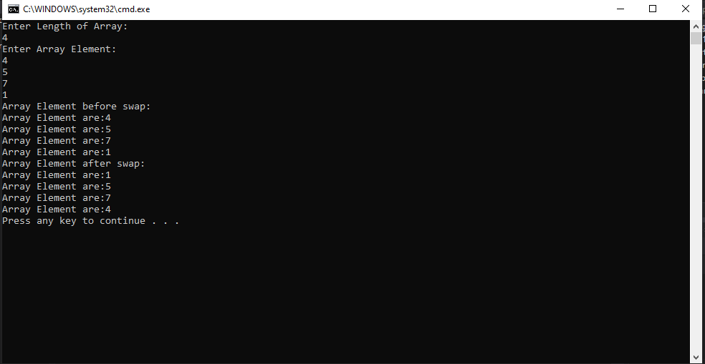

**Question 12:**

using System;

using System.Collections.Generic;

using System.Linq;

using System.Text;

using System.Threading.Tasks;

using System.Text.RegularExpressions;

namespace Program_1

{

class Program

{

static void Main(string[] args)

{

string firstString = "Who worries the Curries";

Console.WriteLine("First String: " + firstString);

string secondString = firstString.Replace("ies", "s");

Console.WriteLine("Second String: " + secondString);

}

}

}

**Output:**

